**C - Type Casting**

<http://www.tutorialspoint.com/cprogramming/c_type_casting.htm>

Copyright © tutorialspoint.com

Type casting is a way to convert a variable from one data type to another data type. For example, if you want to store a long value into a simple integer then you can type cast long to int. You can convert values from one type to another explicitly using the **cast operator** as follows:

(type_name) expression

Consider the following example where the cast operator causes the division of one integer variable by another to be performed as a floating-point operation:

#include <stdio.h>

main()

{

int sum = 17, count = 5;

double mean;

mean = (double) sum / count;

printf("Value of mean : %f\n", mean );

}

When the above code is compiled and executed, it produces the following result:

Value of mean : 3.400000

It should be noted here that the cast operator has precedence over division, so the value of **sum** is first converted to type **double** and finally it gets divided by count yielding a double value.

Type conversions can be implicit which is performed by the compiler automatically, or it can be specified explicitly through the use of the **cast operator**. It is considered good programming practice to use the cast operator whenever type conversions are necessary.

**Integer Promotion**

Integer promotion is the process by which values of integer type "smaller" than **int** or **unsigned int** are converted either to **int** or **unsigned int**. Consider an example of adding a character in an int:

#include <stdio.h>

main()

{

int i = 17;

char c = 'c'; /* ascii value is 99 */

int sum;

sum = i + c;

printf("Value of sum : %d\n", sum );

}

When the above code is compiled and executed, it produces the following result:

Value of sum : 116

Here, value of sum is coming as 116 because compiler is doing integer promotion and converting the value of 'c' to ascii before performing actual addition operation.

**Usual Arithmetic Conversion**

The **usual arithmetic conversions** are implicitly performed to cast their values in a common type. Compiler first performs *integer promotion*, if operands still have different types then they are converted to the type that appears highest in the following hierarchy:

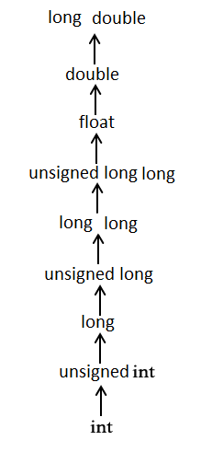

The usual arithmetic conversions are not performed for the assignment operators, nor for the logical operators && and ||. Let us take following example to understand the concept:

#include <stdio.h>

main()

{

int i = 17;

char c = 'c'; /* ascii value is 99 */

float sum;

sum = i + c;

printf("Value of sum : %f\n", sum );

}

When the above code is compiled and executed, it produces the following result:

Value of sum : 116.000000

Here, it is simple to understand that first c gets converted to integer but because final value is double, so usual arithmetic conversion applies and compiler convert i and c into float and add them yielding a float result.